

Submitted by:

Agbisit, Carl Patrick C.

Tan, Carl Stephen C.

Yazaki, Koichi

Submitted to:

Paul John Parreño

Contents

What is Math&Magic? 3

What is OCR? 3

What is system of linear equation? 3

Why did we make it? 3

Table of Revisions 4

Initial Screen 5

Main Page 5

Gallery Page 6

OCR Page 7

Result Page 7

Camera 8

Help Page 8

Application Information Dialog 9

**Figures**

Figure １- Initial Screen 5

Figure ２- Main Page 5

Figure ３- Unselected Image 6

Figure ４- Gallery Page 6

Figure ５- OCR Page 7

Figure ６- Result Page 7

Figure ７- Camera 8

Figure ８- Help Page 8

Figure ９- App Info Dialog 9

What is Math&Magic?

It is an application for calculating algebraic systems of linear equations using OCR as a method of input.

What is OCR?

OCR stands for Optical Character Recognition. It is a technology that enables you to convert different types of documents, such as scanned paper documents, PDF files or images captured by a digital camera into editable and searchable data.

What is system of linear equation?

A system of linear equations (or linear system) is a collection of linear equations involving the same set of variables.

Why did we make it?

System of linear equations can take a lot of time to solve especially as the system grows larger. With OCR becoming more popular and accurate, we explore the possibility of using this technology to make the input of the linear system effortless. In line with this, we use the processing power of computing machines to speed up the process of calculating for the roots to the system of linear equations.

Table of Revisions

|  |  |  |
| --- | --- | --- |
| Revision | Date | Updates/Changes |
| 1.0 | July,7,2014 | Initial UI creation |
| 2.0 | August,17,2014 | Outline Color  Camera View  Gallery Layout  Drop setting functionality |
| 3.0 | October,16,2014 | Gallery Layout  Drop hamburger menu  Camera View  Outline Color  Main Page Button  Application Header  Add Help Page  Add Application Information Page  Icon |

Initial Screen

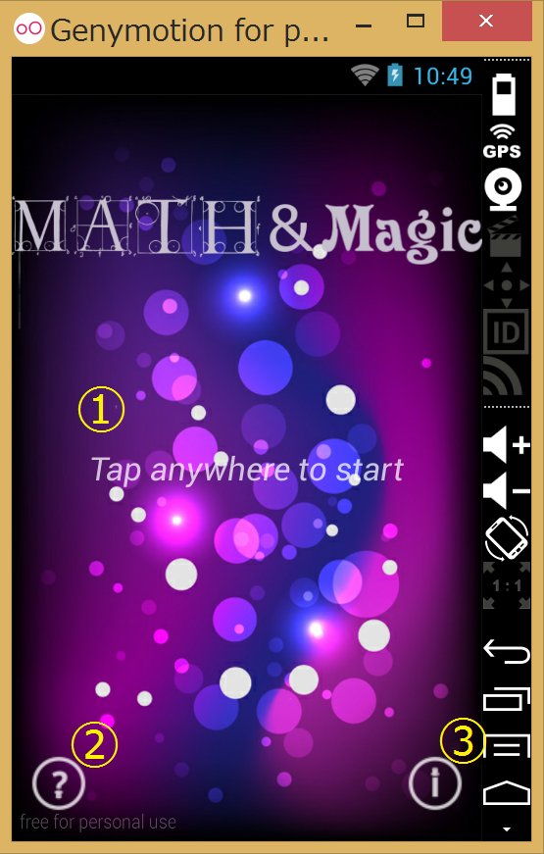

Figure １- Initial Screen

When the user starts the application, this Initial Screen will be shown. The Initial Screen is allows the user to proceed to the Main Page, Help Page or display the application info.

Buttons:

1. Tap anywhere to start
2. Help Button

Through pressing this button, the user can proceed to Help Page.

1. Application Information Button

Through pressing this button, the user is shown a Dialog box containing the application’s information.

Main Page

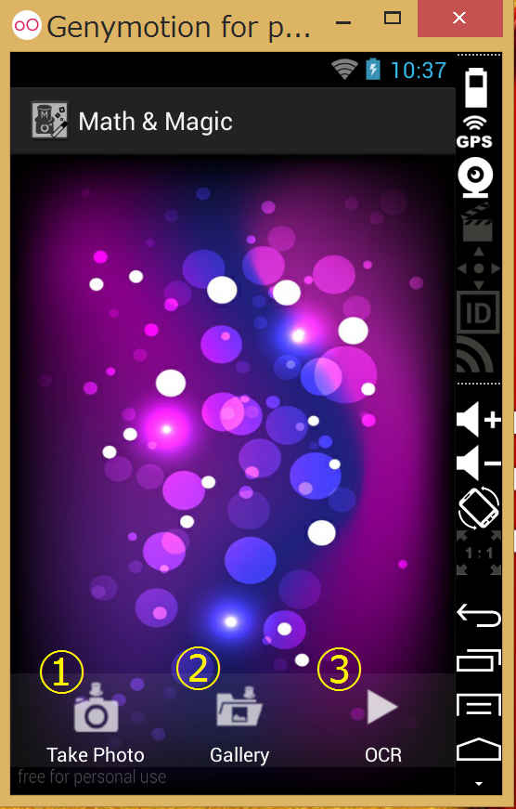

Figure ２- Main Page

The Main Page serves as the control center which allows the user to access the native camera application, getting an image from an app-private gallery as well as performing OCR processing. In the center of the Main Page view, the selected image will be displayed.

Buttons:

1. Take Picture Button

Through pressing this button, the user can proceed to Camera Page.

1. Gallery Button

Through pressing this button, the user can proceed to Gallery Page.

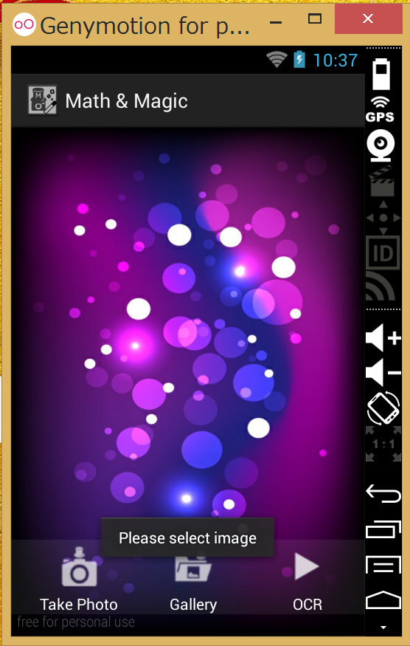

Figure ３- Unselected Image

1. OCR Button

Through pressing this button, the user can proceed to the OCR Page. If the ImageView in the Main page contains an image, the user is allowed to proceed to the OCR process. However, if there is no image inside the ImageView, a notification “Please select image” dialog will be shown.

Gallery Page

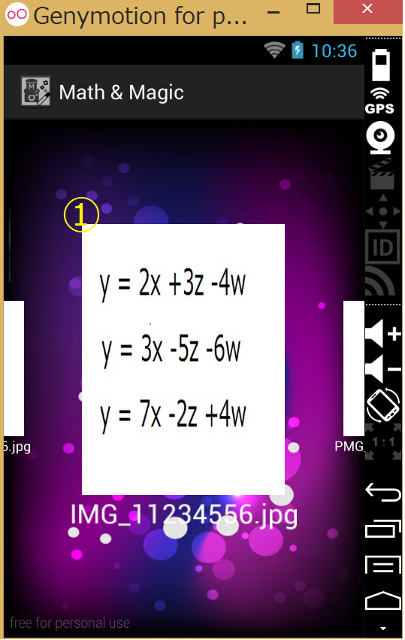

Figure ４- Gallery Page

In the Gallery Page, all the images that are stored in this application will be shown here. The user is allow to select image to pass it to Main Page.

Buttons:

1. Image

Through pressing the gallery image, the user is allowed to go back the Main Page with selected image.

OCR Page

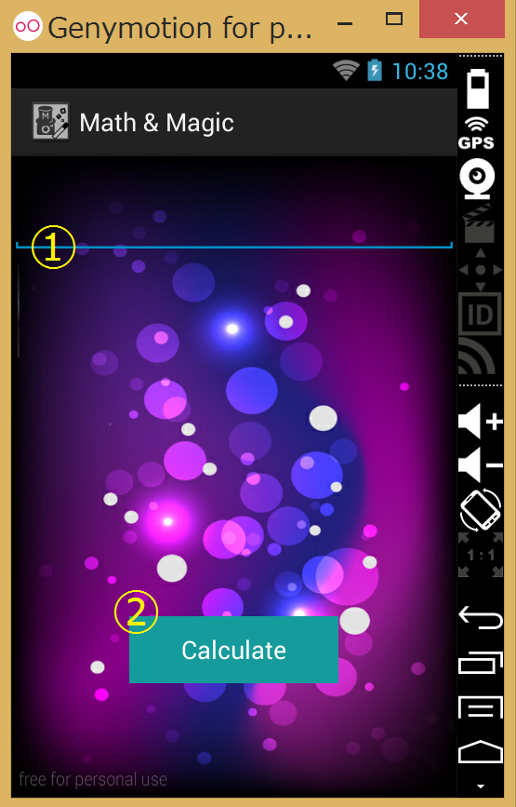

Figure ５- OCR Page

The OCR Page is where OCR process is performed. The result of the OCR process will be shown in the text field above. The user has the permission to edit the text when you press this text field.

Button Description:

1. Editing the field

Through pressing the displayed linear equation, the user is allowed to edit the equation.

1. Calculate Button

Through pressing this button, the user can proceed to Result Page

Result Page

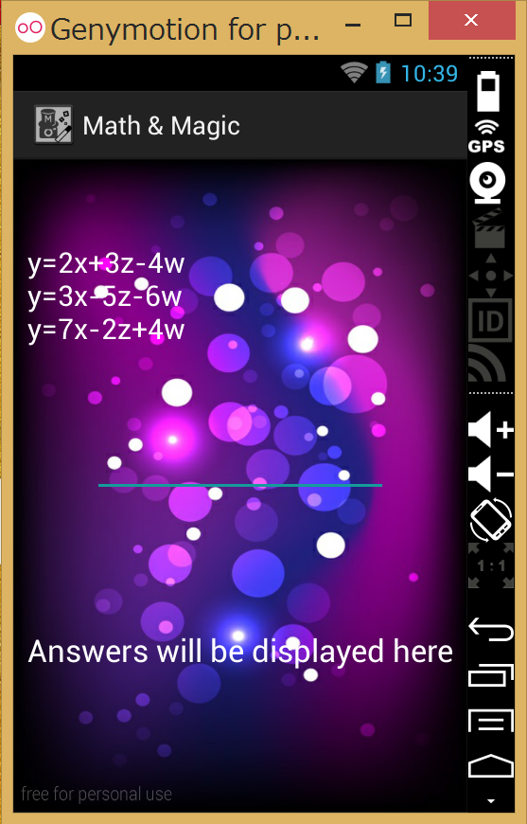

Figure ６- Result Page

In the Result Page, the answers, which are the roots of linear system, will be shown in the page.

Camera

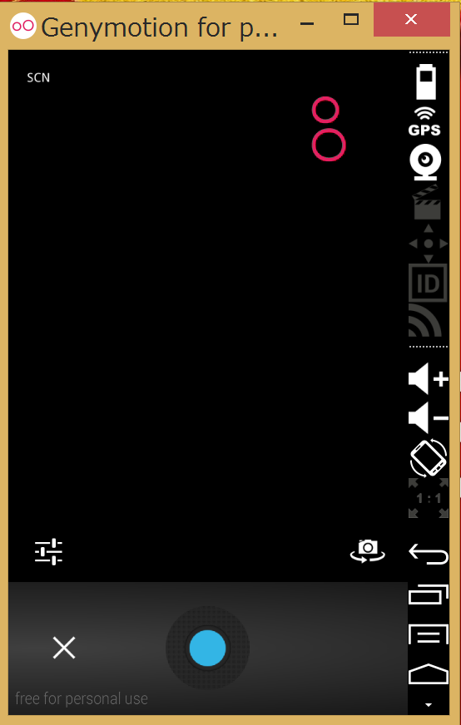

Figure ７- Camera

In the Camera application is using the build-in camera application inside Android.

Help Page

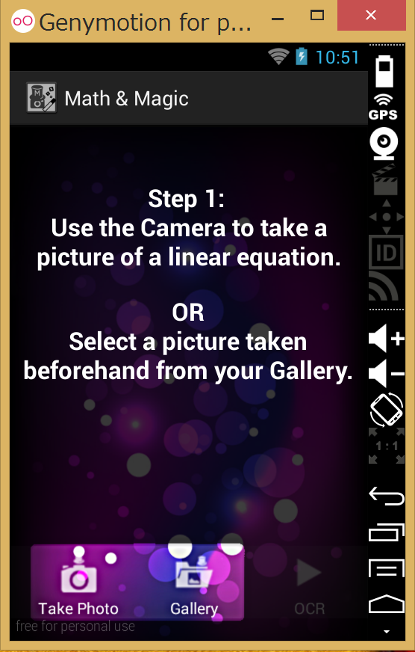In the Help Page, the user will know how to use this application. The screen is swappable to see next page.

Figure ８- Help Page

Application Information Dialog

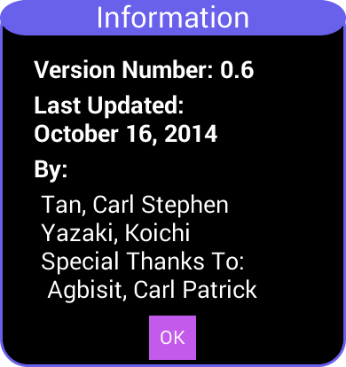

Figure ９- App Info Dialog

In the Application Information Page, all the information regarding version number, last updated, as well as the contributors of this application will be shown. This dialog’s context is the initial startup screen.